JPO 122 Assignment 1 – Mathematics of Physics
Due date: 3rd August 2012

Name:
Student No:
Field Of Study:
Group:
Total:

I am aware of the University of Pretoria’s plagiarism clause and steps that may be taken against me, should I be found guilty. This work is my original effort.

Signature: __________________
Question 1 [8]
Consider vectors $\vec{v}=3.00 \hat{i}+4.00 \hat{j}$ and $\vec{w}$ the vector 13.0 at 22.6° clockwise to the negative x-axis.
- What is the sum ($\vec{v}+\vec{w}$) and difference ($\vec{v}-\vec{w}$) of these two vectors? (4)

$$\vec{w}=-13.0\cos{22.6}\hat{i}+13.0\sin{22.6}\hat{j}$$
$$\vec{v}+\vec{w}=\left(3.00-13.0\cos{22.6}\right)\hat{i}+\left(4.00+13.0\sin{22.6}\right)\hat{j}=-9.00\hat{i}+9.00\hat{j}$$
$$\vec{v}-\vec{w}=\left(3.00+13.0\cos{22.6}\right)\hat{i}+\left(4.00-13.0\sin{22.6}\right)\hat{j}=15.0\hat{i}-0.996\hat{j}$$
- Graphically depict $\vec{v}$, $\vec{w}$ ,$\vec{v}+\vec{w}$ and $\vec{v}-\vec{w}$ on the same set of axes (4)
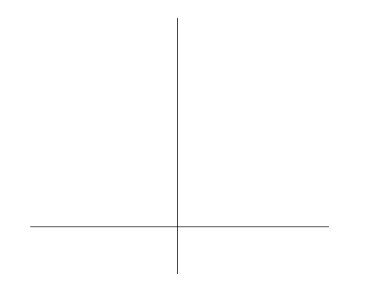
$$\vec{v}$$
$$\vec{w}$$
$$\vec{v}+\vec{w}$$
$$\vec{v}-\vec{w}$$
Question 2 [4]
The volume of fluid in a can is given by $V=πr^{2}h$ where r is the radius of the can and h is the height of the fluid. As the can is filled by fluid the height (in cm) changes as a function of time given by $h=9.0t+5.0t^{2}$. Find $\frac{dV}{dt}$ at $t=3s$ given that $r=4.0 cm$
$$V\left(t\right)=9.0πr^{2}t+5.0πr^{2}t^{2}$$
$$V^{'}(t)=9.0πr^{2}+10.0πr^{2}t$$
$$V^{'}\left(3\right)=9.0π{\left(4.0\right)}^{2}+10.0π{\left(4.0\right)}^{2}3=1960 {cm}^{3}/s$$

Question 3 [3]
Given the following graph:

Find the integral of x between t=0 and t=10s
$$\int_{0}^{10}{v\left(t\right) dt}=area under curve$$
$$=\frac{1}{2}\left(3\right)\left(5\right)+3\left(5\right)+\frac{1}{2}\left(4\right)(5)$$
$$=32.5 m$$

